CRICKET MANAGEMENT SYSTEM
Database Design & Implementation Report

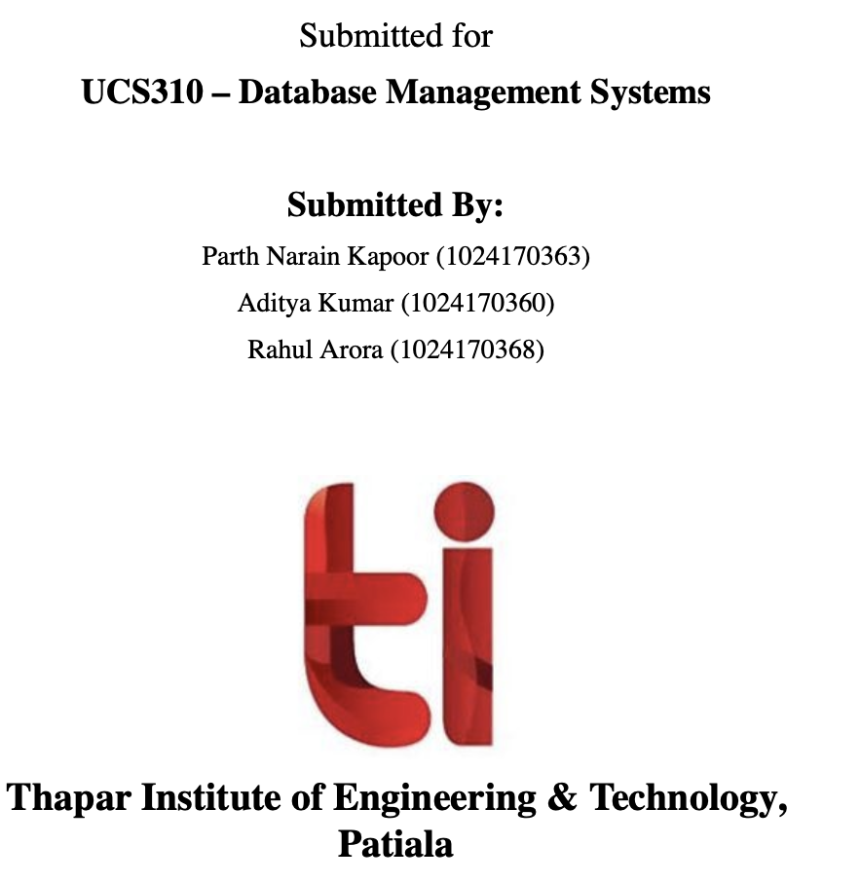
Technology: MySQL / XAMPP | Language: PHP | Year: 2026

1. Project Introduction

The Cricket Management System is a relational database project designed to manage all aspects of professional and domestic cricket data. Built on MySQL and deployed via XAMPP, the system provides structured storage and retrieval of players, teams, match records, performance statistics, and ICC-style rankings.

The project demonstrates advanced database concepts including normalized schema design, stored procedures, user-defined functions, triggers, views, and transaction management — all applied in the context of real-world cricket data.

2. Project Objectives

- Maintain a complete registry of cricket players with their country and role.
- Assign players to national and franchise teams via a relationship table.
- Record match details including venue, date, format (ODI / T20 / Test), and type.
- Track individual player performance (runs, wickets, balls faced) per match.
- Generate and store ICC-style player rankings by format.
- Automate data validation and logging using database triggers.
- Expose computed stats (strike rate, total runs) via stored functions and procedures.
- Support multi-user access with role-based authentication (Admin / User).

3. Database Schema

The database test_db contains eight tables designed following 3NF normalization principles. Each table is described below.

3.1 Users
Stores login credentials and role assignments for system access control.

Column | Data Type | Constraint | Description
user_id | INT | PK, AUTO_INCREMENT | Unique user identifier
username | VARCHAR(100) | UNIQUE, NOT NULL | Login username
password | VARCHAR(255) | NOT NULL | Password
role | ENUM | DEFAULT 'user' | admin or user

3.2 Player
Central entity storing all registered cricket players.

Column | Data Type | Constraint | Description
player_id | INT | PK, AUTO_INCREMENT | Unique player identifier
name | VARCHAR(100) | NOT NULL | Player full name
country | VARCHAR(100) | NOT NULL | Nationality
role | VARCHAR(50) | NOT NULL | Batsman / Bowler / All Rounder / WK

3.3 Team
Stores national and franchise team names.

Column | Data Type | Constraint | Description
team_id | INT | PK, AUTO_INCREMENT | Unique team identifier
team_name | VARCHAR(100) | UNIQUE, NOT NULL | Team name (e.g., India, CSK)

3.4 Match_Details
Records every cricket match with venue, date, format, and type.

Column | Data Type | Constraint | Description
match_id | INT | PK, AUTO_INCREMENT | Unique match identifier
venue | VARCHAR(100) | NOT NULL | Match location
match_date | DATE | NOT NULL | Date of the match
format | ENUM | NOT NULL | ODI, T20, or Test
Match_Type | ENUM | NOT NULL | International or Domestic

3.5 Plays_For
Junction table linking players to teams (many-to-many relationship).

Column | Data Type | Constraint | Description
assignment_id | INT | PK, AUTO_INCREMENT | Unique assignment ID
player_id | INT | FK → Player | Reference to player
team_id | INT | FK → Team | Reference to team
start_date | DATETIME | DEFAULT NOW() | Assignment start timestamp

3.6 Performance
Stores per-match performance statistics for each player.

Column | Data Type | Constraint | Description
performance_id | INT | PK, AUTO_INCREMENT | Unique performance record
player_id | INT | FK → Player | Player reference
match_id | INT | FK → Match_Details | Match reference
runs | INT | DEFAULT 0, CHECK ≥ 0 | Runs scored
wickets | INT | DEFAULT 0, CHECK ≥ 0 | Wickets taken
balls_faced | INT | DEFAULT 0, CHECK ≥ 0 | Balls faced

3.7 Ranking
Stores ICC-style player rankings by format.

Column | Data Type | Constraint | Description
ranking_id | INT | PK, AUTO_INCREMENT | Unique ranking ID
player_id | INT | FK → Player | Player reference
format | VARCHAR(100) | — | Format category (ODI, T20, etc.)
rank_position | INT | — | Numeric rank position

3.8 Player_Delete_Log
Audit log automatically populated when a player record is deleted.

Column | Data Type | Constraint | Description
log_id | INT | PK, AUTO_INCREMENT | Log entry ID
player_name | VARCHAR(100) | — | Name of deleted player
deleted_at | TIMESTAMP | DEFAULT NOW() | Deletion timestamp

4. Sample Data

4.1 Players

ID | Name | Country | Role
1 | Virat Kohli | India | Batsman
2 | Rohit Sharma | India | Batsman
3 | Jasprit Bumrah | India | Bowler
4 | MS Dhoni | India | Wicket Keeper
5 | Ben Stokes | England | All Rounder
6 | Babar Azam | Pakistan | Batsman

4.2 Teams

ID | Team Name
1 | India
2 | Australia
3 | England
4 | Pakistan
5 | CSK
6 | MI
7 | RCB
8 | GT

4.3 Performance Records

Perf. ID | Player ID | Match ID | Runs | Wickets | Balls Faced
1 | 1 | 1 | 120 | 0 | 100
2 | 2 | 1 | 85 | 0 | 75
3 | 3 | 1 | 10 | 4 | 12
4 | 4 | 2 | 60 | 0 | 40
5 | 5 | 3 | 95 | 2 | 120
6 | 6 | 2 | 77 | 0 | 55

5. SQL Queries
The following SQL queries were implemented and tested in the Cricket Management System project.
1. 01. Correlated: players who have at least one performance record
SELECT
p.player_id,
p.name,
p.country
FROM `Player` p
WHERE EXISTS (
SELECT 1
FROM `Performance` per
WHERE per.player_id = p.player_id
)
ORDER BY p.name;
2. 02. Correlated: players who scored more than 50 in any match
SELECT
p.player_id,
p.name,
p.country
FROM `Player` p
WHERE EXISTS (
SELECT 1
FROM `Performance` per
WHERE per.player_id = p.player_id
AND per.runs > 50
)
ORDER BY p.country, p.name;
3. 03. Correlated: players whose highest score is above 75
SELECT
p.name,
p.country,
(SELECT MAX(per.runs)
FROM `Performance` per
WHERE per.player_id = p.player_id) AS highest_score
FROM `Player` p
WHERE (SELECT MAX(per.runs)
FROM `Performance` per
WHERE per.player_id = p.player_id) > 75
ORDER BY highest_score DESC;
4. 04. Correlated: players whose total runs are above 200
SELECT
p.name,
p.country,
(SELECT SUM(per.runs)
FROM `Performance` per
WHERE per.player_id = p.player_id) AS total_runs
FROM `Player` p
WHERE (SELECT SUM(per.runs)
FROM `Performance` per
WHERE per.player_id = p.player_id) > 200
ORDER BY total_runs DESC;
5. 05. Correlated: teams that currently have at least one active player
SELECT
t.team_id,
t.team_name
FROM `Team` t
WHERE EXISTS (
SELECT 1
FROM `Plays_For` pf
WHERE pf.team_id = t.team_id
AND pf.end_date IS NULL
)
ORDER BY t.team_name;
6. 06. Correlated: matches where at least one player scored 100 or more
SELECT
m.match_id,
m.venue,
m.match_date
FROM `Match_Details` m
WHERE EXISTS (
SELECT 1
FROM `Performance` per
WHERE per.match_id = m.match_id
AND per.runs >= 100
)
ORDER BY m.match_date;
7. 07. Correlated: players who are not present in the Ranking table
SELECT
p.player_id,
p.name,
p.country
FROM `Player` p
WHERE NOT EXISTS (
SELECT 1
FROM `Ranking` r
WHERE r.player_id = p.player_id
)
ORDER BY p.name;
8. 08. Correlated: ranked players whose rank is 10 or better
SELECT
p.name,
r.format,
r.rank_position
FROM `Player` p
JOIN `Ranking` r ON r.player_id = p.player_id
WHERE r.rank_position <= (
SELECT 10
FROM `Player` p2
WHERE p2.player_id = p.player_id
)
ORDER BY r.rank_position;
9. 09. Join: complete player, team, match, and performance report
SELECT
p.name,
t.team_name,
m.venue,
m.match_date,
per.runs,
per.wickets,
per.balls_faced
FROM `Player` p
JOIN `Plays_For` pf ON pf.player_id = p.player_id
JOIN `Team` t ON t.team_id = pf.team_id
JOIN `Performance` per ON per.player_id = p.player_id
JOIN `Match_Details` m ON m.match_id = per.match_id
ORDER BY m.match_date, t.team_name, per.runs DESC;
10. 10. Join with aggregation: total runs by team
SELECT
t.team_name,
SUM(per.runs) AS team_runs
FROM `Team` t
JOIN `Plays_For` pf ON pf.team_id = t.team_id
JOIN `Player` p ON p.player_id = pf.player_id
JOIN `Performance` per ON per.player_id = p.player_id
GROUP BY t.team_id, t.team_name
ORDER BY team_runs DESC;
11. 11. Left join: all teams with number of players
SELECT
t.team_name,
COUNT(pf.player_id) AS total_players
FROM `Team` t
LEFT JOIN `Plays_For` pf ON pf.team_id = t.team_id
GROUP BY t.team_id, t.team_name
ORDER BY total_players DESC;
12. 12. Join with HAVING: venues with more than 5 matches
SELECT
m.venue,
COUNT(*) AS total_matches
FROM `Match_Details` m
GROUP BY m.venue
HAVING COUNT(*) > 5
ORDER BY total_matches DESC;
13. 13. Self join: pairs of players from the same country
SELECT
p1.name AS player_one,
p2.name AS player_two,
p1.country
FROM `Player` p1
JOIN `Player` p2 ON p1.country = p2.country AND p1.player_id < p2.player_id
ORDER BY p1.country, p1.name
LIMIT 30;
14. 14. Join with ranking table: ranked player details
SELECT
r.rank_position,
r.format,
p.name,
p.country
FROM `Ranking` r
JOIN `Player` p ON p.player_id = r.player_id
ORDER BY r.format, r.rank_position;
15. 15. Anti-join: players who have no ranking record
SELECT
p.player_id,
p.name,
p.country
FROM `Player` p
LEFT JOIN `Ranking` r ON r.player_id = p.player_id
WHERE r.ranking_id IS NULL
ORDER BY p.name;
16. 16. Join with date filter: performances in May 2008
SELECT
p.name,
m.venue,
per.runs,
m.match_date
FROM `Player` p
JOIN `Performance` per ON per.player_id = p.player_id
JOIN `Match_Details` m ON m.match_id = per.match_id
WHERE m.match_date BETWEEN '2008-05-01' AND '2008-05-31'
ORDER BY m.match_date, per.runs DESC;
17. 17. Multi-table join: team-wise player runs
SELECT
t.team_name,
p.name,
SUM(per.runs) AS total_runs
FROM `Team` t
JOIN `Plays_For` pf ON pf.team_id = t.team_id
JOIN `Player` p ON p.player_id = pf.player_id
JOIN `Performance` per ON per.player_id = p.player_id
GROUP BY t.team_id, t.team_name, p.player_id, p.name
ORDER BY t.team_name, total_runs DESC;
18. 18. Aggregate: country-wise player count
SELECT
country,
COUNT(*) AS total_players
FROM `Player`
GROUP BY country
ORDER BY total_players DESC;
19. 19. Aggregate: venue-wise match count
SELECT
venue,
COUNT(*) AS total_matches
FROM `Match_Details`
GROUP BY venue
ORDER BY total_matches DESC;
20. 20. Aggregate with average: average runs by each player
SELECT
p.name,
ROUND(AVG(per.runs), 2) AS average_runs
FROM `Player` p
JOIN `Performance` per ON per.player_id = p.player_id
GROUP BY p.player_id, p.name
ORDER BY average_runs DESC;
21. 21. CASE query: classify innings by runs scored
SELECT
p.name,
per.runs,
CASE
WHEN per.runs >= 100 THEN 'Century'
WHEN per.runs >= 50 THEN 'Half Century'
WHEN per.runs >= 25 THEN 'Good Start'
ELSE 'Low Score'
END AS innings_type
FROM `Performance` per
JOIN `Player` p ON p.player_id = per.player_id
ORDER BY per.runs DESC;
22. 22. Date query: matches played in May 2008
SELECT
match_id,
venue,
match_date,
DAYNAME(match_date) AS match_day
FROM `Match_Details`
WHERE match_date BETWEEN '2008-05-01' AND '2008-05-31'
ORDER BY match_date;
23. 23. View query: top 10 scorers from Top_Scorers view
SELECT
player_id,
name,
country,
total_runs
FROM `Top_Scorers`
LIMIT 10;
24. 24. View query: team players from Team_Players view
SELECT
team_name,
name,
role,
start_date
FROM `Team_Players`
ORDER BY team_name, name;
25. 25. Function query: calculate strike rate for each innings
SELECT
p.name,
per.runs,
per.balls_faced,
`Calculate_Strike_Rate`(per.runs, per.balls_faced) AS strike_rate
FROM `Performance` per
JOIN `Player` p ON p.player_id = per.player_id
WHERE per.balls_faced > 0
ORDER BY strike_rate DESC;
26. 26. UNION query: list all countries and venues in one column
SELECT country AS cricket_place
FROM `Player`
UNION
SELECT venue AS cricket_place
FROM `Match_Details`
ORDER BY cricket_place;
27. 27. UPDATE query inside transaction
START TRANSACTION;
UPDATE `Users`
SET role = 'admin'
WHERE username = 'user';
ROLLBACK;
28. 28. INSERT and DELETE query inside transaction
START TRANSACTION;
INSERT INTO `Users`(`username`, `password`, `role`)
VALUES ('temporary_user', 'temp123', 'user');
DELETE FROM `Users`
WHERE username = 'temporary_user';
COMMIT;
29. 29. Procedure call: get total runs of player id 1
CALL `Get_Player_Runs`(1);
30. 30. Procedure call: regenerate and display rankings
CALL `Generate_Rankings`();
SELECT
r.rank_position,
p.name,
p.country,
r.format
FROM `Ranking` r
JOIN `Player` p ON p.player_id = r.player_id
ORDER BY r.rank_position
LIMIT 20;
/*!40101 SET CHARACTER_SET_CLIENT=@OLD_CHARACTER_SET_CLIENT */;
/*!40101 SET CHARACTER_SET_RESULTS=@OLD_CHARACTER_SET_RESULTS */;
/*!40101 SET COLLATION_CONNECTION=@OLD_COLLATION_CONNECTION */;
-- =====================================================
-- END OF COMPLETE PROJECT FILE
-- =====================================================

5. Views

Three SQL views were created to simplify common data access patterns:

View 1: Top_Scorers
Aggregates total runs per player using JOIN on Player and Performance tables, ordered by total_runs descending. Provides a leaderboard of the highest-scoring players across all matches.

View 2: Team_Players
Three-way join across Team, Plays_For, and Player tables. Returns a flat list of every player along with their team name and playing role — useful for roster management.

View 3: Match_Summary
Summarises each match with a count of participating players (performance entries). Uses a LEFT JOIN to include matches with no recorded performances.

6. Stored Procedures & Functions

6.1 Function: Calculate_Strike_Rate
A deterministic user-defined function that accepts runs (INT) and balls (INT) as parameters and returns a DECIMAL(10,2) strike rate computed as (runs / balls) × 100. Returns 0 if balls = 0 to prevent division by zero.

6.2 Procedure: Get_Player_Runs
Accepts a player ID (pid INT) and returns the player's name along with their cumulative runs across all matches via a GROUP BY query on the Performance table.

6.3 Procedure: Generate_Rankings
Truncates the Ranking table and repopulates it using a DENSE_RANK() window function over aggregated runs per player. This automates the full ranking refresh cycle in a single CALL statement.

6.4 Procedure: Cursor_Player_List
Demonstrates MySQL cursor usage by iterating over all players in the Player table and selecting each name sequentially using a FETCH loop inside a stored procedure.

7. Triggers

Trigger Name | Event | Table | Purpose
Prevent_Negative_Runs | BEFORE INSERT | Performance | Raises SQLSTATE 45000 if runs < 0
Log_Player_Delete | AFTER DELETE | Player | Inserts deleted player name into Player_Delete_Log
Prevent_Duplicate_Assignment | BEFORE INSERT | Plays_For | Blocks re-assigning the same player to the same team

Together these three triggers enforce data integrity at the database level, independent of application-layer validation.

8. Transaction Management

The project includes a sample transaction that demonstrates COMMIT and SAVEPOINT usage. Two new team records (RCB and GT) are inserted within a single transaction block. A SAVEPOINT is created after the first insert, allowing partial rollback if the second insert fails. The transaction is committed only after both inserts succeed, ensuring atomicity.

9. Entity Relationships Summary

Relationship | Cardinality | Description
Player ↔ Team (via Plays_For) | M : N | A player can play for multiple teams; a team has many players
Player ↔ Performance | 1 : N | One player can have many performance records
Match_Details ↔ Performance | 1 : N | One match can have many player performances
Player ↔ Ranking | 1 : N | One player can have rankings across multiple formats

10. Entity-Relationship Diagram

The following ER diagram illustrates all entities, attributes, relationships, and cardinalities of the Cricket Management System database design:
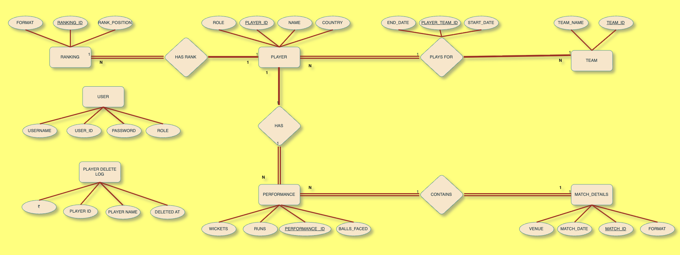

The diagram shows five core entities: PLAYER (central), TEAM, MATCH_DETAILS, PERFORMANCE, and RANKING. The PLAYS_FOR relationship connects PLAYER to TEAM in an M:N cardinality, resolved through a junction table. The HAS relationship connects PLAYER to PERFORMANCE (1:N), and the CONTAINS relationship connects MATCH_DETAILS to PERFORMANCE (1:N). The HAS RANK relationship connects PLAYER to RANKING (1:N). All primary key attributes are underlined in the diagram.

11. Final Outcomes and Deliverables
_______________________________________________________________________________________________
The Cricket Management System was successfully designed and implemented as a complete relational database solution. Every project objective related to schema design, normalization, SQL programming, triggers, views, stored procedures, and transaction management was completed and tested thoroughly.
11.1 Deliverables Checklist
Deliverable | Details | Status
Normalized Schema (3NF) | 8 tables with PKs, FKs, CHECK, UNIQUE, ENUM constraints | Done
DDL – CREATE TABLE | Complete database structure for all entities | Done
DML – INSERT | Realistic cricket player and match data | Done
DML – UPDATE | Role updates and ranking modifications | Done
DML – DELETE | Deletion support with logging triggers | Done
SELECT Queries | 30 advanced SQL queries with joins and subqueries | Done
Views (3) | Top_Scorers, Team_Players, Match_Summary | Done
Stored Procedures (3) | Generate_Rankings, Get_Player_Runs, Cursor_Player_List | Done
Stored Functions (1) | Calculate_Strike_Rate | Done
Triggers (3) | Validation, duplicate prevention, delete logs | Done
Cursor | Cursor-based player iteration | Done
Transaction Management | SAVEPOINT, COMMIT, ROLLBACK | Done
ACID Properties | Integrity maintained through transactions | Done

11.2 Key Technical Achievements
• The schema follows Third Normal Form (3NF), minimizing redundancy and improving consistency.
• Complex many-to-many relationships were handled efficiently using the Plays_For junction table.
• Triggers automatically prevent invalid data insertion and maintain audit logs.
• Stored procedures automate ranking generation and player statistics retrieval.
• The Calculate_Strike_Rate function demonstrates reusable procedural SQL programming.
• Views simplify reporting and provide meaningful summaries for analysis.
• Transaction management demonstrates ACID properties using SAVEPOINT and ROLLBACK.
• The project architecture supports future scalability and advanced cricket analytics.
11.3 Future Scope and Enhancements
• Integration with live cricket score APIs.
• Player analytics and performance dashboards.
• Tournament scheduling and fixture management.
• Web-based admin panel integration.
• Mobile application support.
• Cloud deployment and backup support.
• Advanced indexing and optimization for large datasets.

11. Conclusion

The Cricket Management System successfully demonstrates a complete relational database solution from schema design through to advanced procedural SQL. The project covers all major RDBMS concepts including:

- Normalized multi-table schema (3NF) with appropriate primary and foreign keys.
- Views for simplified data access and reporting.
- A user-defined function for computed statistics (strike rate).
- Stored procedures for encapsulated business logic and cursor-based iteration.
- Triggers for automated data validation, duplicate prevention, and audit logging.
- Transaction management with SAVEPOINT for controlled multi-step inserts.
- Role-based user management with admin and user access levels.
- Sample data covering national teams, franchise teams, international and domestic matches.

The system is deployment-ready on any XAMPP / MySQL stack and provides a scalable foundation for a full-featured cricket statistics web application.

